# Project Design Phase-I Solution Architecture

|  |  |
| --- | --- |
| Date | 04 November 2023 |
| Team ID | NM2023TMID11490 |
| Project Name | DRUG TRACEABILITY |
| Maximum Marks | 4 Marks |

**Solution Architecture:**

Solution architecture is a complex process – with many sub-processes – that bridges the gap between business problems and technology solutions. Its goals are to:

* Find the best tech solution to solve existing business problems.
* Describe the structure, characteristics, behavior, and other aspects of the software to project stakeholders.
* Define features, development phases, and solution requirements.
* Provide specifications according to which the solution is defined, managed, and delivered.

# Example - Solution Architecture Diagram:

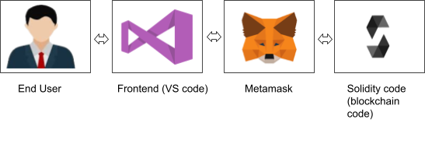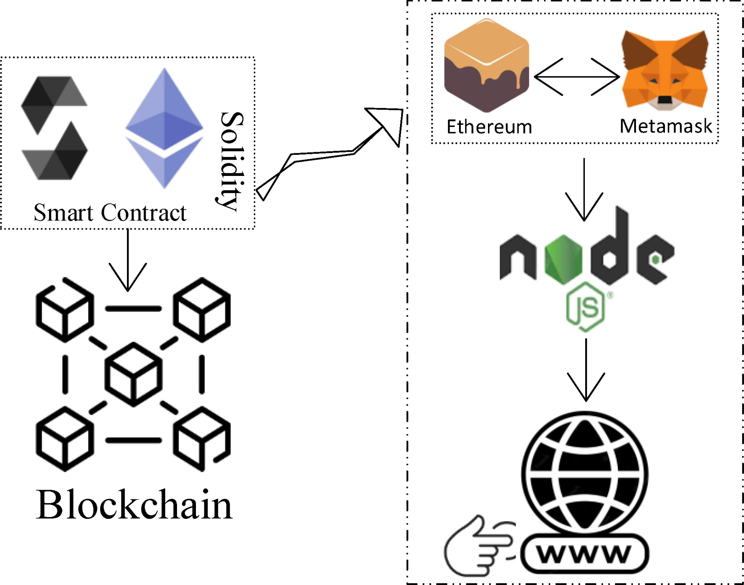

**Prerequisite**

1. download node.js : [Node.js](https://nodejs.org/en)
2. download vs code: [**Li4nk**](https://code.visualstudio.com/download)
3. download metamask : <https://metamask.io/>

# Steps to complete the project Step 1:-

1. Open the Zip file and download the zip file. Extract all zip files

# Step 2 :

1. Open vs code in the left top select open folder. Select extracted file and open .
2. Select the projectname.sol file and copy the code.
3. Open the remix ide platform and create a new file by giving the name of projectname.sol and paste the code which you copied from vs code.
4. Click on solidity compiler and click compile the projectname.sol
5. Deploy the smart contract by clicking on the deploy and run transaction.
6. select injected provider - MetaMask. In environment
7. Click on deploy. Automatically MetaMask will open and give confirmation. You will get a pop up click on ok.
8. In the Deployed contract you can see one address copy the address.
9. Open vs code and search for the connector.js. In contract.js you can paste the address at the bottom of the code. In export const address.
10. Save the code.

# Step 3:

open file explorer

1. Open the extracted file and click on the folder.
2. Open src, and search for utiles.

3 . You can see the frontend files. Select all the things at the top in the search bar by clicking alt+ A. Search for cmd

1. Open cmd enter commands npm install

npm bootstrap npm start

1. It will install all the packages and after completing it will open {LOCALHOST IP

ADDRESS} copy the address and open it to chrome so you can see the frontend of your project.